### 

Software Requirement Specification

Văn Lang Admissions

# Revision Table

|  |  |  |  |
| --- | --- | --- | --- |
| Author | Date | Reason for changes | Version |
| Khoi Nguyen | 8/12/2016 | Initial the document | 1.0 |
| Khoi Nguyen , Hien Nguyen | 13/12/2016 | Update non-functional requirement , detail quality attribute scenarios , product scope.  Update operating environment , assumption. | 1.1 |
| Khoi Nguyen , Hien Nguyen | 20/12/2016 | Update Orther Non-Functional Requirements | 1.2 |
| Khoi Nguyen | 15/1/2017 | Update Product functionality , Users & Characteristics | 1.3 |

Table of Contents

Revision Table 1

1. INTRODUCTION 3

1.1. Purpose 3

1.2. Product scope 3

1.3. Definitions, acronyms and abbreviations 4

1.4. Audience 5

2. Overall description 5

2.1. Product perspective 5

2.2. Product functionality 6

2.3. Users and characteristics 6

2.4. Operating environment 7

2.5. Design and implementation constraints 7

2.6. User documentation 8

2.7. Assumptions and dependencies 8

3. Specific requirements 8

3.1. External interface requirements 8

3.2. Functional requirements 9

3.3 Business rules 11

APPENDIX A: REFERENCES 12

# INTRODUCTION

## Purpose

This document provides a complete description of the features and requirements of the Web Văn Lang Admissions project. This document is used as commitment between customer and development team about output product and development process‘s rules.

This document provide for project team member:

* Used to support project team can understand the overview of the system.
* Used to support the design-oriented analysis and design system architecture and detail design.
* Used to support software testing to create test plan and acceptance test.

## Product scope

Văn Lang Admissions is web page introduce information and admissions news of Văn Lang University. At the same time allow the aptitude exam candidates can register online.

Based on customer requirements , BSS Team divide this system into three releases :

Release 1 : 4 module

* Manage News
* Manage Categories
* Manage Account
* Manage Resource

Release 2 : 3 module

* Manage Examination
* Manage Q/A
* Manage Homepage

Release 3 : 3 module

* Manage Pop-ups
* Manage Banners
* Change Languages

Some features may be included in the software but not required:

* View the admissions video
* Comment the admissions video

## Definitions, acronyms and abbreviations

This following table describes key terms and important acronyms in this project:

|  |  |  |
| --- | --- | --- |
| No. | Term | Definition |
| 1 | BSS | Base Steps Solution Team who develop this project |
| 2 | PM | Project Manager |
| 3 | UC | Usecase |
| 4 | SRS | Software Requirement Specification |
| 5 | UI | User Interface |

## Audience

|  |  |
| --- | --- |
| Intended Audience | Reading Suggestions |
| Project manager | Functional requirements, business constraints to estimate project. |
| Architect and designer | Use cases, constraints, quality attributes to architect and design the system. |
| Tester | Use cases to develop system test, integration test, test plan and acceptance test. |
| Customer | Use-case diagram, use-case description, quality Attribute. |

# Overall description

## Product perspective

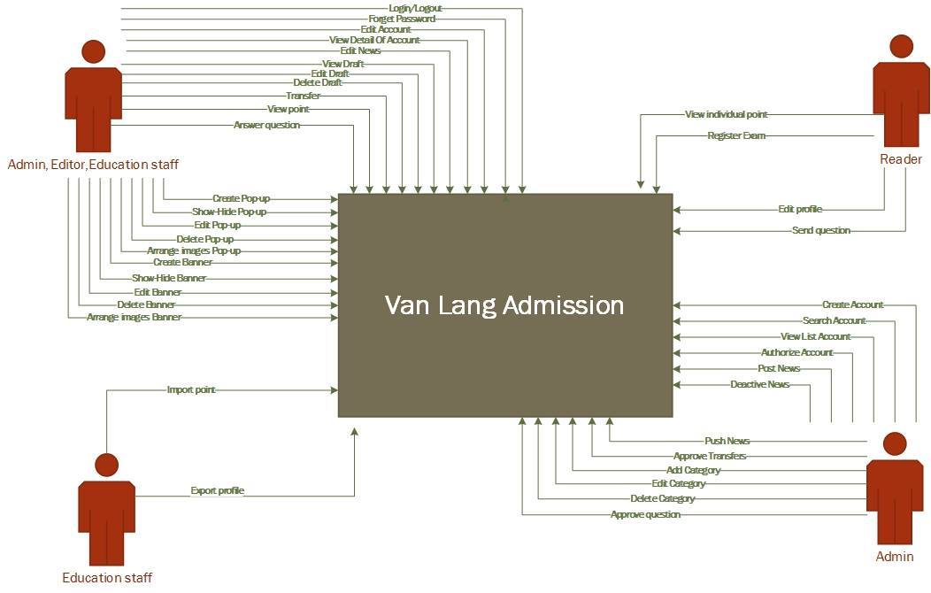

## Product functionality

|  |  |  |
| --- | --- | --- |
| Modul | Description | Priority |
| Manage Accounts | This modul help user manages account of system | High |
| Manage News | This modul help user manages all the news on website | High |
| Manage Categories | This modul help user manages all Categories of website | High |
| Manage Examination | This modul help user manages about issues related to examinations | High |
| Manage Q/A | This modul help user manages Q/A | High |
| Manage Pop-ups | This modul help user manages Pop-ups | High |
| Manage Banners | This modul help user manages Banners | High |
| Change Languages | This modul help user change languages | Medium |
| Manage Homepage | This module help user manages Homepage of VanLang Admission | High |

## Users and characteristics

|  |  |  |
| --- | --- | --- |
| Id | Role | Responsible |
| SA | System Admin | Manage everything related to system website |
| CA | Content Admin | Manage content of website that show for user |
| ED | Editor | Create news, content for website |
| ES | Education Staff | Export student's information,import score, news related to education |
| US | User | Who follow website to get information |
| MS | Mail Server | Send mail inclue account information for actor |
| FS | Facebook SDK | Handle news that share by User |

## Operating environment

User Computer:

* CPU: Intel Pentium 4 or higher.
* RAM: 1GB or higher.
* Resolution: 800x600
* Web browser:
  + Chrome
  + Firefox
  + Internet explorer
  + Cốc cốc

Server :

|  |  |  |  |  |
| --- | --- | --- | --- | --- |
| Item | Webserver (minimal) | Webserver (recommended) | Combined Web & Database Server (minimal) | Combined Web & Database Server (recommended) |
| Processor | 1,6 GHz CPU | 2x1,6 GHz CPU | 2x1,6 GHz CPU | 4x1,6 GHz CPU |
| RAM | 1,75 GB RAM | 3,5 GB RAM | 3,5 GB RAM | 7 GB RAM |
| HDD | 1x 300 GB of free space or more is recommended for the webshop data (non-system drive is preferred)  1x 300 GB of free space or more is recommended for the software that is listed in the software requirements (system drive) | | | |
| Operation System | Linux | | | |

## Design and implementation constraints

* Business constraint

BC1: Project is during 30 weeks.

Start date: 1/10/2016

End date: 30/4/2016

* Technical constraint

TC1: Database: mongodb, elasticsearch, redit

TC2: Development language: JavaScript

TC3: Framework: AngularJs

TC4: Platform: NodeJs

## User documentation

When our system is used, we will give documents:

* User guide
* Installation instructions

## Assumptions and dependencies

Assumption

* AS1: System has 3000 enroll each year.
* AS2: Response about 500 user access into system in 2 seconds , > 500 user response about 4-5s

Dependence

To be define.

# Specific requirements

## External interface requirements

Refer to BSS_UsecaseDescription_V1.0 document

## Functional requirements

|  |  |  |  |  |
| --- | --- | --- | --- | --- |
|  | USE CASE ID | FUNCTION | ENTITY | DESCRIPTION |
| Manage Accounts | UC-MA-01 | Log-in | CA, SA, ED, ES | Actor log in website |
| UC-MA-02 | Log-out | CA,SA, ED, ES | Actor log out website |
| UC-MA-03 | Create Account | SA | Actor create new account |
| UC-MA-04 | Edit Account | CA, SA,ED, ES | Actor edit information of their account |
| UC-MA-05 | Search Account | SA | Actor search account |
| UC-MA-06 | Forget Password | CA,SA, ED, ES, MS | Actor forget password and request to get new password form email |
| UC-MA-07 | View Detail Of Account | SA | Actor view the detail of their account |
| UC-MA-08 | View List Account | SA | Actor view list of accounts |
| UC-MA-09 | Authorize | SA | Actor authorizes for account |
| UC-MA-10 | Activate Account | SA | Actor active account has been disable |
| UC-MA-11 | Deactivate Account | SA | Actor deactive accounts no longer working |
| Manage News | UC-MN-01 | View News | SA,CA, ED, ES, US | Actor view news in the website |
| UC-MN-02 | Post | CA | Actor posts the news |
| UC-MN-03 | View Draft | CA, ED, ES | Actor view draft of the post |
| UC-MN-04 | Edit Draft | CA, ED, ES | Actor edit draft of the post |
| UC-MN-05 | Delete Draft | CA, ED, ES | Actor delete draft of the post |
| UC-MN-06 | Transfer | CA, ED, ES | Actor transfer the post to somebody |
| UC-MN-07 | Approve | CA | Actor approve the post from someone transfers to him |
| UC-MN-08 | Deactive | CA | Actor deactives the news |
| UC-MN-09 | Search | CA, ED, ES, US | Actor search the news which they want to view |
| UC-MN-10 | Sort | CA, ED, ES, US | Actor sort the new follow the alphabet, posted date. |
| UC-MN-11 | Push | CA | Actor push the news to the top |
| UC-MN-12 | Create News | CA,ED,ES | Actor create a news |
| UC-MN-13 | Share News | US,FS | Actor share news to social network |
| Manage Categories | UC-MC-01 | View | SA,CA, ED, ES, US | Actor view the categories |
| UC-MC-02 | Add | CA | Actor adds new category |
| UC-MC-03 | Edit | CA | Actor edits the exist category |
| UC-MC-04 | Delete | CA | Actor deletes the category |
| Manage Examination | UC-ME-01 | View point | CA, ED, ES | Actor view list points of candidates |
| UC-ME-02 | View individual point | US | Actor views point follow candidate code |
| UC-ME-03 | Register Exam | US, MS | Actor registers skill examination and get information from email |
| UC-ME-04 | Import point | ES | Actor import list of point into the system |
| UC-ME-05 | Export profile | ES | Actor exports profile of cadidate |
| UC-ME-06 | Edit profile | US | Actor edits profile |
| UC-ME-07 | Create Exam | ES | Actor create exam for candidate can join in |
| Manage Q/A | UC-MQA-01 | Send question | US | Actor send the question |
| UC-MQA-02 | Answer question | CA, ED, ES, MS | Actor answer the question and send to User |
| UC-MQA-03 | View question | SA,CA, ED, ES, US | Actor view the approved question |
| UC-MQA-04 | Approve question | CA | If the question and the answer is good, Actor will approve and post it |
| UC-MQA-05 | Search Question | SA,CA, ED, ES, US | Actor search the question which is posted |
| Manage Pop-ups | UC-PU-01 | Create | CA | Actor create new pop-up |
| UC-PU-02 | View | SA,CA, ED, ES, US | Actor view the pop-up on website |
| UC-PU-03 | Show-Hide | CA | Actor show or hide the pop-up |
| UC-PU-04 | Edit | CA | Actor edit informations of pop-up |
| UC-PU-05 | Delete | CA | Actor delete pop-up |
| UC-PU-06 | Arrange images | CA | Actor arrange images in pop-up |
| Manage Banners | UC-MB-01 | Create | CA | Actor create new banner |
| UC-MB-02 | View | SA,CA, ED, ES, US | Actor view the banner on website |
| UC-MB-03 | Show-Hide | CA | Actor show or hide the banner |
| UC-MB-04 | Edit | CA | Actor edit information of banner |
| UC-MB-05 | Delete | CA | Actor delete the banner |
| UC-MB-06 | Arrange images | CA | Actor arrange images in banner |
| Change Languages | UC-CLG-01 | Change Languages | SA,CA, ED, ES, US | Actor change language |
| Manage Homepage | UC-MH-01 | Add | CA, ED, ES | Actor add field to show on homepage |
| UC-MH-02 | Edit | CA, ED, ES | Actor edit field |
| UC-MH-03 | Delete | CA, ED, ES | Actor delete field |

## 3.3 Business rules

|  |  |
| --- | --- |
| ID | Description |
|  |  |
|  |  |

1. ORTHER NON-FUNCTIONAL REQUIREMENTS

|  |  |  |  |
| --- | --- | --- | --- |
| Id | Quality Attribute | Description | Priority |
| SQA-P01 | Performance | When users use the system to view the necessary information, the system will respond quickly, display results in 2 seconds | High |
| SQA-P02 | Education staffs can import point into system average 1000 points will import about 4 seconds | High |
| SQA-A01 | Availability | When Web server unresponsive, can re-operation quickly | High |
| SQA-C01 | Scalability | System can expand limit number of users | High |
| SQA-U01 | Usability | System has friendly interface and easy to use | Medium |
| SQA-R01 | Portability | Users can use the system on mobile platform | Medium |
| SQA-M01 | Modifiability | The system can add/delete/modify other functions later | Medium |
| SQA-S01 | Security | System can authorize user’s informations | Low |

Detail quality attribute scenarios : BSS_QualityScenario_V1.1.docx

1. ORTHER REQUIREMENTS

# APPENDIX A: REFERENCES